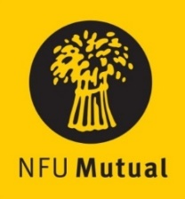 

**Welsh Livestock Champion of the Year Award**

# ENTRY FORM

**Name:**

**Address:**

**Tel No. Mobile No.**

(Please state in the appropriate sections why the nominee should be considered)

1. **How nominee started in the industry and how his/her role has grown, include details of the livestock managed**

1. **Their role in the care and management of livestock**
2. **How they intend developing the business**
3. **Nominee’s vision for the future of the industry**
4. **How nominee incorporates health and safety in their day-to-day activities**

[please use a separate sheet if necessary] _________________________________________________________________________________________

Name and address of person submitting the nomination if different from name above:

Please return the completed entry form either by email to [clare.williams@nfu.org.uk](mailto:clare.williams@nfu.org.uk) or by post marked ‘Livestock Champion Award’ **no later than 4.30pm** on **Monday 28th October 2024**, to: NFU Cymru, Agriculture House, Royal Welsh Showground, Builth Wells, LD2 3TU.

By completing this form you are agreeing to have this information sent to NFU Cymru for the purposes of contacting you and the nominee (if different) about this award. Read our [Privacy Policy](https://www.nfu-cymru.org.uk/media/kownjmey/nfu-privacy-policy.pdf) to find out about how we respect your data.