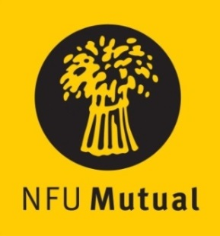 

**Welsh Dairy Stockperson of the Year Award**

# ENTRY FORM

**Name:**

**Address:**

**Tel No. Mobile No.**

(Please state in the appropriate sections why the nominee should be considered)

1. **Details of the dairy stock nominee manages**
2. **How nominee started in the industry and how his/her role has grown**

1. **Nominee’s role in the care and management of dairy stock**

[please use a separate sheet if necessary]

__________________________________________________________________________________________

Name and address of person submitting the nomination if different from name above:

Please return the completed entry form either by email to [clare.williams@nfu.org.uk](mailto:clare.williams@nfu.org.uk) or by post marked ‘Dairy Stockperson Award’ **no later than** **5pm on Friday 27th September 2024**, to: NFU Cymru, Agriculture House, Royal Welsh Showground, Builth Wells, LD2 3TU.

By completing this form you are agreeing to have this information sent to NFU Cymru for the purposes of contacting you and the nominee (if different) about this award. Read our [Privacy Policy](https://www.nfu-cymru.org.uk/media/kownjmey/nfu-privacy-policy.pdf) to find out about how we respect your data.